**SPECIAL NOTICE**

**On Tuesday, November 12, 2013, the Office of Mineral Resources on behalf of the State Mineral and Energy Board advertised in the “The Notice of Publication” for receipt of sealed bids on or before noon on Tuesday, December 10, 2013 for State Leases to be awarded upon Tract Nos. 43646 through 43690, inclusive, at its December 11, 2013 Lease Sale. Within the said advertisement was an incorrect description. By Virtue of this public notice, Tract No. 43676, Lafourche Parish was incorrectly advertised and is hereby corrected as follows to describe four land tracts:**

**TRACT 43691 - Lafourche Parish, Louisiana**

All lands, including lands now or formerly constituting the beds and bottoms of all water bodies of every nature and description, owned by and not presently under mineral lease as of December 11, 2013 from the State of Louisiana, situated in Lafourche Parish, Louisiana, and being more fully described as follows: That certain tract or parcel of land containing 53.36 acres, more or less, situated in Section 13, Township 17 South Range 19 East, Lafourche, Louisiana, and being described as Lot 2 of Section 13 in that Survey dated September 21, 1857 and is also described in Patent #1140563, dated September 1, 1953, more fully described as being a Division of State Lands Tract No. 3 29 037 containing approximately **53.36 acres**, all as more particularly outlined on a plat on file in the Office of Mineral Resources, Department of Natural Resources. All bearings, distances and coordinates are based on Louisiana Coordinate System of 1927, (North or South Zone), where applicable.

NOTE: The above description of the Tract nominated for lease has been provided and corrected, where required, exclusively by the nomination party. Any mineral lease selected from this Tract and awarded by the Louisiana State Mineral and Energy Board shall be without warranty of any kind, either express, implied, or statutory, including, but not limited to, the implied warranties of merchantability and fitness for a particular purpose. Should the mineral lease awarded by the Louisiana State Mineral and Energy Board be subsequently modified, cancelled or abrogated due to the existence of conflicting leases, operating agreements, private claims or other future obligations or conditions which may affect all or any portion of the leased Tract, it shall not relieve the Lessee of the obligation to pay any bonus due thereon to the Louisiana State Mineral and Energy Board, nor shall the Louisiana State Mineral and Energy Board be obligated to refund any consideration paid by the Lessor prior to such modification, cancellation, or abrogation, including, but not limited to, bonuses, rentals and royalties.

NOTE: The State of Louisiana does hereby reserve, and this lease shall be subject to, the imprescriptible right of surface use in the nature of a servitude in favor of the Department of Natural Resources, including its Offices and Commissions, for the sole purpose of implementing, constructing, servicing and maintaining approved coastal zone management and/or restoration projects. Utilization of any and all rights derived under this lease by the mineral lessee, its agents, successors or assigns, shall not interfere with nor hinder the reasonable surface use by the Department of Natural Resources, its Offices or Commissions, as herein above reserved.

|  |  |  |  |  |  |  |
| --- | --- | --- | --- | --- | --- | --- |
| Bidder | Cash Payment | Price/ Acre | Rental | Oil | Gas | Other |
|  |  |  |  |  |  |  |
|  |  |  |  |  |  |  |
|  |  |  |  |  |  |  |
|  |  |  |  |  |  |  |

Applicant: UEBER DEVELOPMENT

|  |
| --- |
|  |

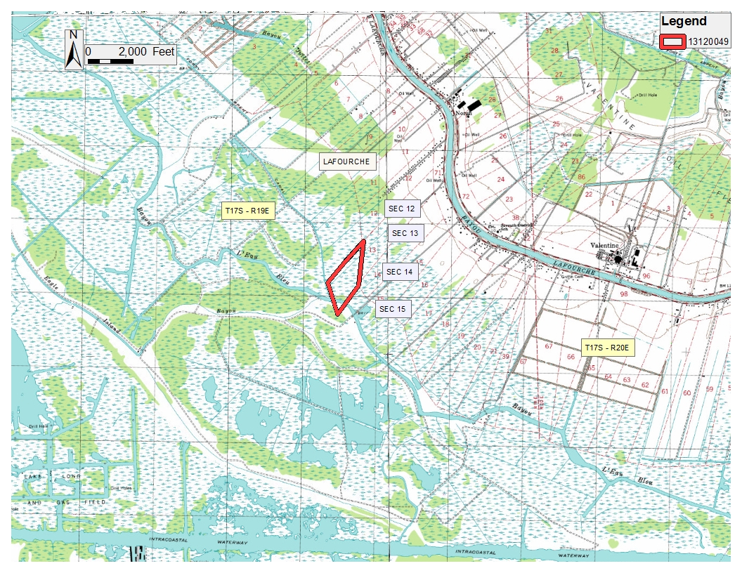

Office of Mineral Resources, Acres: 53.36 Tract Number: 43691

**TRACT 43692 - Lafourche Parish, Louisiana**

All lands, including lands now or formerly constituting the beds and bottoms of all water bodies of every nature and description, owned by and not presently under mineral lease as of December 11, 2013 from the State of Louisiana, situated in Lafourche Parish, Louisiana, and being more fully described as follows: That certain tract or parcel of land containing 60.20 acres, more or less, situated in Section 15, Township 17 South Range 19 East, Lafourche, Louisiana, and being described as Lot 2 of Section 15 in that Survey dated September 21, 1857 and is also described in Patent #1140563, dated September 1, 1953, more fully described as being a Division of State Lands Tract No. 3 29 038 containing approximately **60.20 acres**, all as more particularly outlined on a plat on file in the Office of Mineral Resources, Department of Natural Resources. All bearings, distances and coordinates are based on Louisiana Coordinate System of 1927, (North or South Zone), where applicable.

NOTE: The above description of the Tract nominated for lease has been provided and corrected, where required, exclusively by the nomination party. Any mineral lease selected from this Tract and awarded by the Louisiana State Mineral and Energy Board shall be without warranty of any kind, either express, implied, or statutory, including, but not limited to, the implied warranties of merchantability and fitness for a particular purpose. Should the mineral lease awarded by the Louisiana State Mineral and Energy Board be subsequently modified, cancelled or abrogated due to the existence of conflicting leases, operating agreements, private claims or other future obligations or conditions which may affect all or any portion of the leased Tract, it shall not relieve the Lessee of the obligation to pay any bonus due thereon to the Louisiana State Mineral and Energy Board, nor shall the Louisiana State Mineral and Energy Board be obligated to refund any consideration paid by the Lessor prior to such modification, cancellation, or abrogation, including, but not limited to, bonuses, rentals and royalties.

NOTE: The State of Louisiana does hereby reserve, and this lease shall be subject to, the imprescriptible right of surface use in the nature of a servitude in favor of the Department of Natural Resources, including its Offices and Commissions, for the sole purpose of implementing, constructing, servicing and maintaining approved coastal zone management and/or restoration projects. Utilization of any and all rights derived under this lease by the mineral lessee, its agents, successors or assigns, shall not interfere with nor hinder the reasonable surface use by the Department of Natural Resources, its Offices or Commissions, as herein above reserved.

|  |  |  |  |  |  |  |
| --- | --- | --- | --- | --- | --- | --- |
| Bidder | Cash Payment | Price/ Acre | Rental | Oil | Gas | Other |
|  |  |  |  |  |  |  |
|  |  |  |  |  |  |  |
|  |  |  |  |  |  |  |
|  |  |  |  |  |  |  |

Applicant: UEBER DEVELOPMENT

|  |
| --- |
|  |

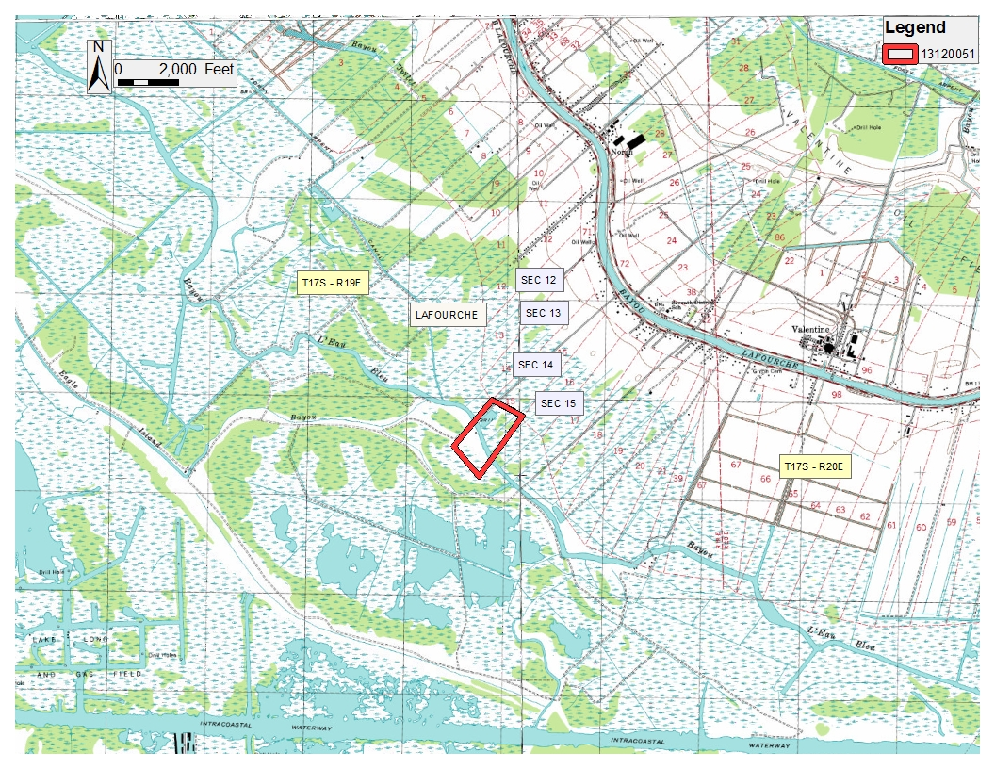

Office of Mineral Resources, Acres: 60.2 Tract Number: 43692

**TRACT 43693 - Lafourche Parish, Louisiana**

All lands, including lands now or formerly constituting the beds and bottoms of all water bodies of every nature and description, owned by and not presently under mineral lease as of December 11, 2013 from the State of Louisiana, situated in Lafourche Parish, Louisiana, and being more fully described as follows: That certain tract or parcel of land containing 49.72 acres, more or less, situated in Section 17, Township 17 South Range 19 East, Lafourche, Louisiana, and being described as Lot 2 of Section 17 in that Survey dated September 21, 1857 and is also described in Patent #1140563, dated September 1, 1953, more fully described as being a Division of State Lands Tract No. 3 29 039 containing approximately **49.72 acres**, all as more particularly outlined on a plat on file in the Office of Mineral Resources, Department of Natural Resources. All bearings, distances and coordinates are based on Louisiana Coordinate System of 1927, (North or South Zone), where applicable.

NOTE: The above description of the Tract nominated for lease has been provided and corrected, where required, exclusively by the nomination party. Any mineral lease selected from this Tract and awarded by the Louisiana State Mineral and Energy Board shall be without warranty of any kind, either express, implied, or statutory, including, but not limited to, the implied warranties of merchantability and fitness for a particular purpose. Should the mineral lease awarded by the Louisiana State Mineral and Energy Board be subsequently modified, cancelled or abrogated due to the existence of conflicting leases, operating agreements, private claims or other future obligations or conditions which may affect all or any portion of the leased Tract, it shall not relieve the Lessee of the obligation to pay any bonus due thereon to the Louisiana State Mineral and Energy Board, nor shall the Louisiana State Mineral and Energy Board be obligated to refund any consideration paid by the Lessor prior to such modification, cancellation, or abrogation, including, but not limited to, bonuses, rentals and royalties.

NOTE: The State of Louisiana does hereby reserve, and this lease shall be subject to, the imprescriptible right of surface use in the nature of a servitude in favor of the Department of Natural Resources, including its Offices and Commissions, for the sole purpose of implementing, constructing, servicing and maintaining approved coastal zone management and/or restoration projects. Utilization of any and all rights derived under this lease by the mineral lessee, its agents, successors or assigns, shall not interfere with nor hinder the reasonable surface use by the Department of Natural Resources, its Offices or Commissions, as herein above reserved.

|  |  |  |  |  |  |  |
| --- | --- | --- | --- | --- | --- | --- |
| Bidder | Cash Payment | Price/ Acre | Rental | Oil | Gas | Other |
|  |  |  |  |  |  |  |
|  |  |  |  |  |  |  |
|  |  |  |  |  |  |  |
|  |  |  |  |  |  |  |

Applicant: UEBER DEVELOPMENT

|  |
| --- |
|  |

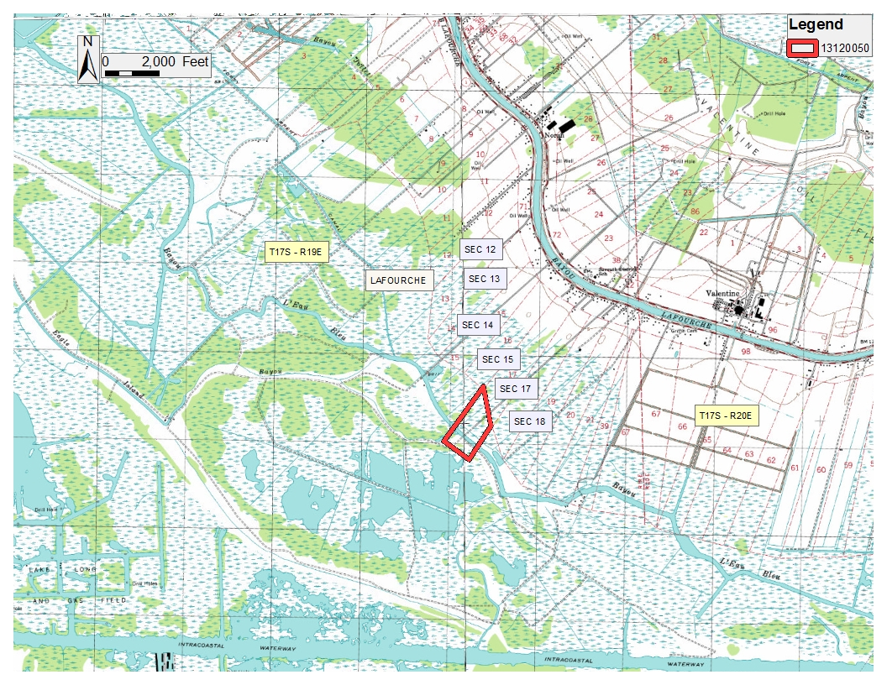

Office of Mineral Resources, Acres: 49.72 Tract Number: 43693

**TRACT 43694 - Lafourche Parish, Louisiana**

All lands, including lands now or formerly constituting the beds and bottoms of all water bodies of every nature and description, owned by and not presently under mineral lease as of December 11, 2013 from the State of Louisiana, situated in Lafourche Parish, Louisiana, and being more fully described as follows: That certain tract or parcel of land containing 8.04 acres, more or less, situated in Section 19, Township 17 South Range 19 East, Lafourche, Louisiana, and being described as Lot 2 of Section 19 in that Survey dated September 21, 1857 and is also described in Patent #1140563, dated September 1, 1953, more fully described as being a Division of State Lands Tract No. 3 29 040 containing approximately **8.04 acres**, all as more particularly outlined on a plat on file in the Office of Mineral Resources, Department of Natural Resources. All bearings, distances and coordinates are based on Louisiana Coordinate System of 1927, (North or South Zone), where applicable.

NOTE: The above description of the Tract nominated for lease has been provided and corrected, where required, exclusively by the nomination party. Any mineral lease selected from this Tract and awarded by the Louisiana State Mineral and Energy Board shall be without warranty of any kind, either express, implied, or statutory, including, but not limited to, the implied warranties of merchantability and fitness for a particular purpose. Should the mineral lease awarded by the Louisiana State Mineral and Energy Board be subsequently modified, cancelled or abrogated due to the existence of conflicting leases, operating agreements, private claims or other future obligations or conditions which may affect all or any portion of the leased Tract, it shall not relieve the Lessee of the obligation to pay any bonus due thereon to the Louisiana State Mineral and Energy Board, nor shall the Louisiana State Mineral and Energy Board be obligated to refund any consideration paid by the Lessor prior to such modification, cancellation, or abrogation, including, but not limited to, bonuses, rentals and royalties.

NOTE: The State of Louisiana does hereby reserve, and this lease shall be subject to, the imprescriptible right of surface use in the nature of a servitude in favor of the Department of Natural Resources, including its Offices and Commissions, for the sole purpose of implementing, constructing, servicing and maintaining approved coastal zone management and/or restoration projects. Utilization of any and all rights derived under this lease by the mineral lessee, its agents, successors or assigns, shall not interfere with nor hinder the reasonable surface use by the Department of Natural Resources, its Offices or Commissions, as herein above reserved.

|  |  |  |  |  |  |  |
| --- | --- | --- | --- | --- | --- | --- |
| Bidder | Cash Payment | Price/ Acre | Rental | Oil | Gas | Other |
|  |  |  |  |  |  |  |
|  |  |  |  |  |  |  |
|  |  |  |  |  |  |  |
|  |  |  |  |  |  |  |

Applicant: UEBER DEVELOPMENT

|  |
| --- |
|  |

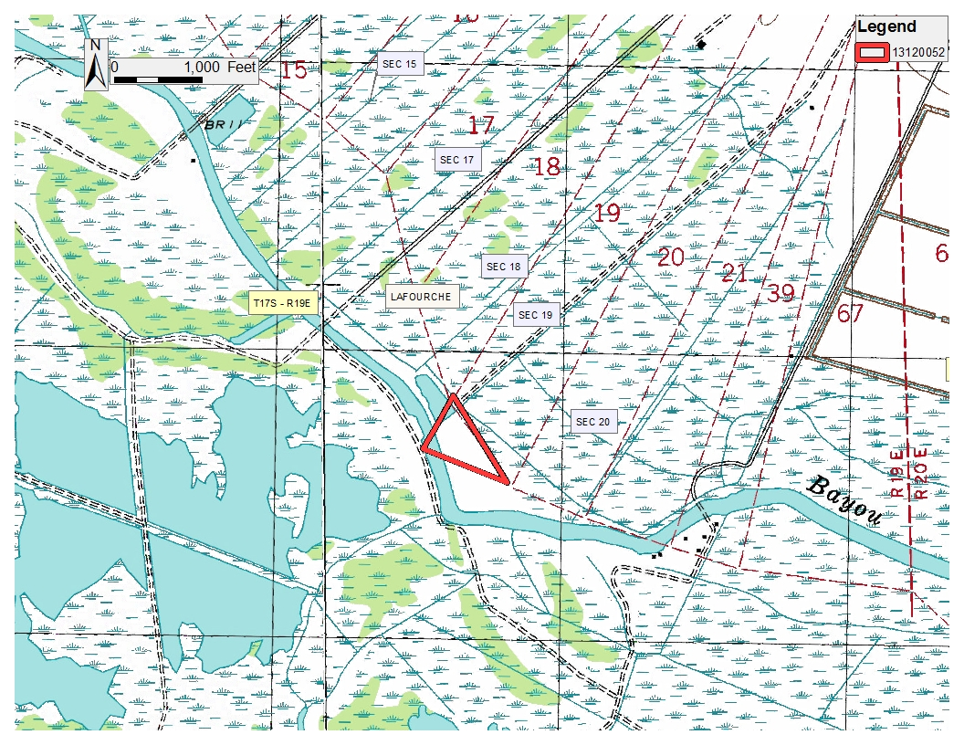

Office of Mineral Resources, Acres: 8.04 Tract Number: 43694